**Directorate of Human Resources V- 1.0**

EMPLOYEE TIMESHEET USER MANUAL DOCUMENT

09/06/2020

Sharjah HR Technical

Information Technology

|  |  |  |
| --- | --- | --- |
| Version | Action By | Dated |
| 1.0 | Initial Document | 09-06-2020 |
|  |  |  |
|  |  |  |
|  |  |  |
|  |  |  |
|  |  |  |

Contents

1. Module Details 2

2. Kentico Admin Part for Admin User 17

**Sharjah HR Employee Timesheet**

# Module Details

**Timesheet User Manual for User**

* **Login:** From this module User can Login with their valid Username and Password.

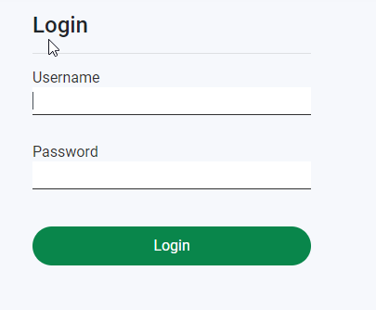

Fig: 1

* **Time Sheet**: From this module user can fill up their task details.

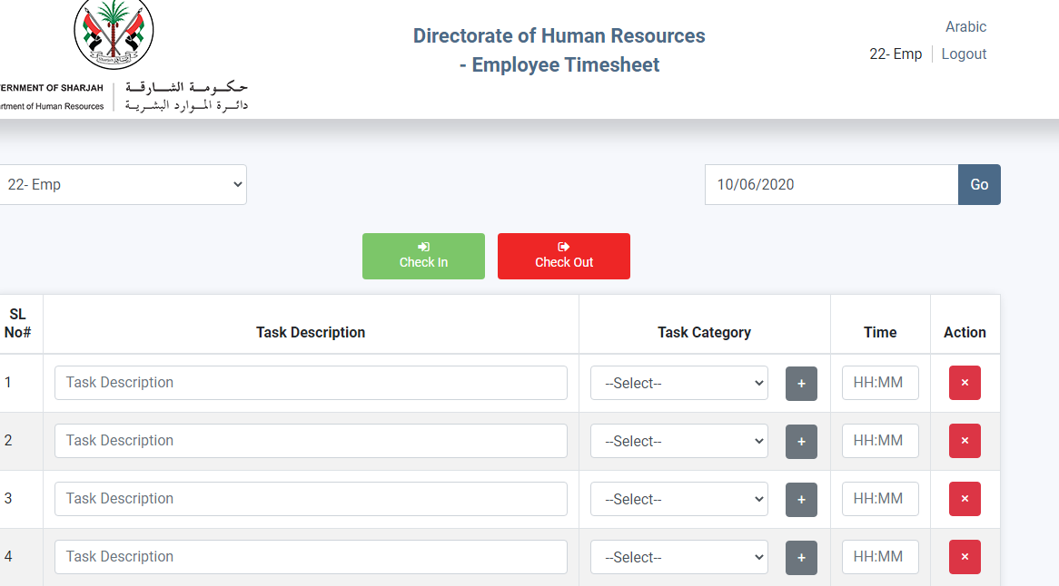

Fig: 2

* By default there are five rows in the task grid. If any employees need to fill up more than 5 task then he/she need to click on “Add Row” button.
* Task description and time is mandatory fields.
* Task category is an optional fields. To add new task category just click on this button. A pop pup will be open and enter task category name and save it. See Fig: 3.

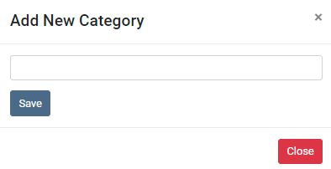

Fig: 3

* To delete/add task details of a previous date, select that date from the date time picker and Click on Go button and Delete or Add record. See fig: 4
* To find out the task details of a particulars date, just select that date from the date time picker. See fig: 4

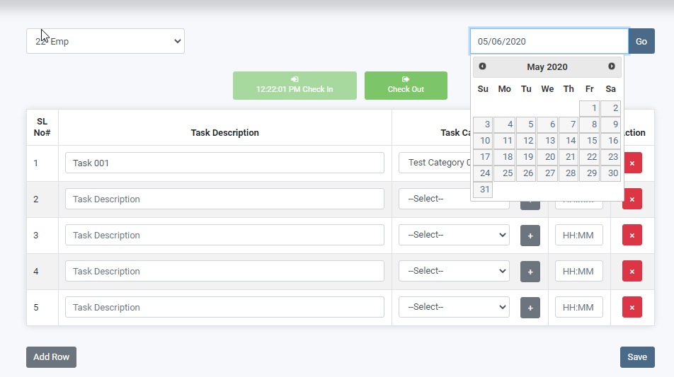

Fig: 4

* **Time Sheet Report** From this report User can view their own task details report by selecting the time range and also download the excel sheet. Fig: 5

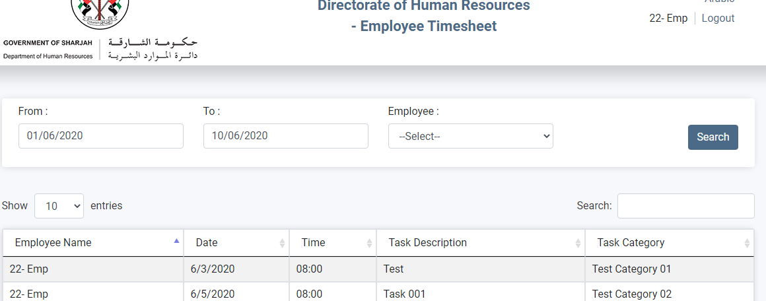

Fig: 5

* **Check In and Check Out time**: In timesheetUser Just click on chek in and check out button to enter the check in and check out time. Fig: 6

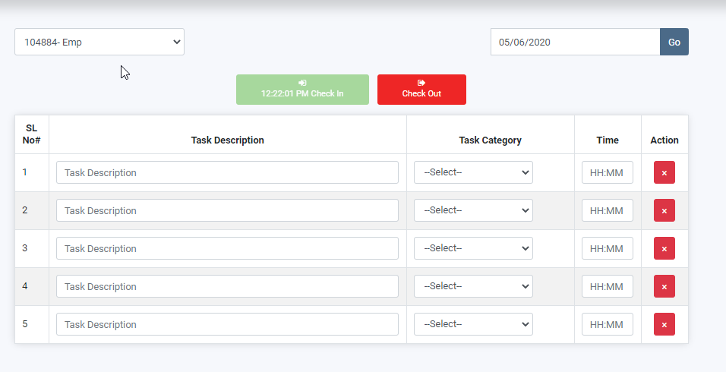

**Fig: 6**

* **CheckIn Status Report:** from this report User can view their own check in and check out time details report by selecting the date range. See fig: 7

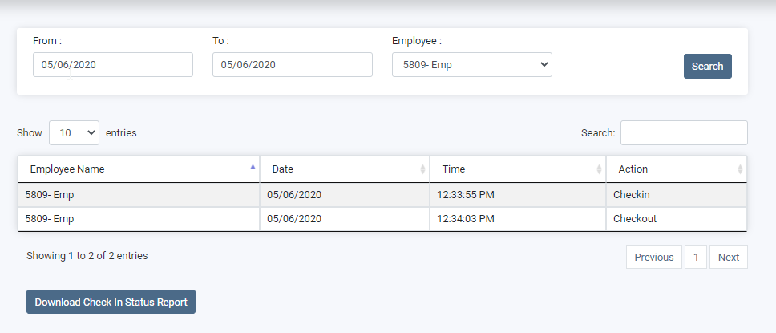

fig: 7

* **Task Category:** From this module User can add, edit or delete their own task category name. see fig: 8

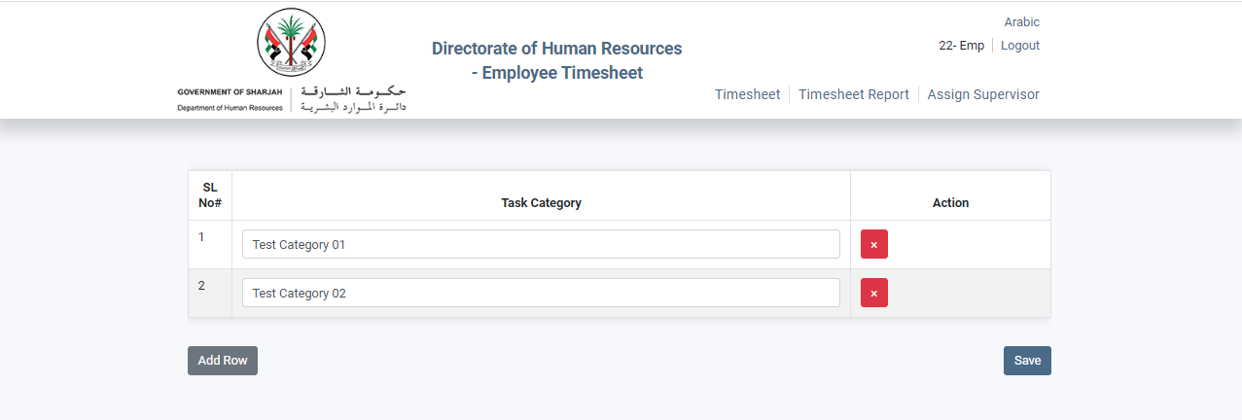

Fig: 8

**Timesheet User Manual for Supervisor User**

* **Login:** From this module Supervisor User can Login with their valid Username and Password.



Fig: 9

* **Time Sheet**: From this module Supervisor user can fill up their task details.



Fig: 10

* If user is supervisor he can view other user task details assigned to him by Admin user. See fig: 11. In fig: 11 there is no “Save“ or “Add Row” button



Fig:11

* By default there are five rows in the task grid. If any employees need to fill up more than 5 task then he/she need to click on “Add Row” button.
* Task description and time is mandatory fields.
* Task category is an optional fields. To add new task category just click on this button. A pop pup will be open and enter task category name and save it. See Fig: 11.



Fig: 11

* To delete/add task details of a particulars date, select that date from the date time picker and Click on Go button. See fig: 12
* To find out the task details of a particulars date, just select that date from the date time picker. See fig: 12



Fig: 12

* **Time Sheet Report** From this report Supervisor User can view their own and assigned user task details report by selecting the date range and also select user from Employee dropdown list and also download the excel sheet. Fig: 13



Fig: 13

* **Check In and Check Out time**: In timesheetSupervisor user just click on chek in and check out button to enter the check in and check out time. Fig: 14



**Fig: 14**

* **CheckIn Status Report:** from this report Supervisor user can view their own and assigned user check in and check out time details report by selecting the date range and also selecting user from Employee dropdown list . See fig: 15



fig: 15

* **Task Category:** From this module Supervisor User can add, edit or delete their own task category name. see fig: 16



Fig: 16

**Timesheet User Manual for Admin User**

* **Login:** From this module Admin User can Login with their valid Username and Password.



Fig: 17

* **Assign Supervisor:** From this module only Admin user can view this menu and Admin user can assign multiple employees of a department under another or same department employee. See fig: 18

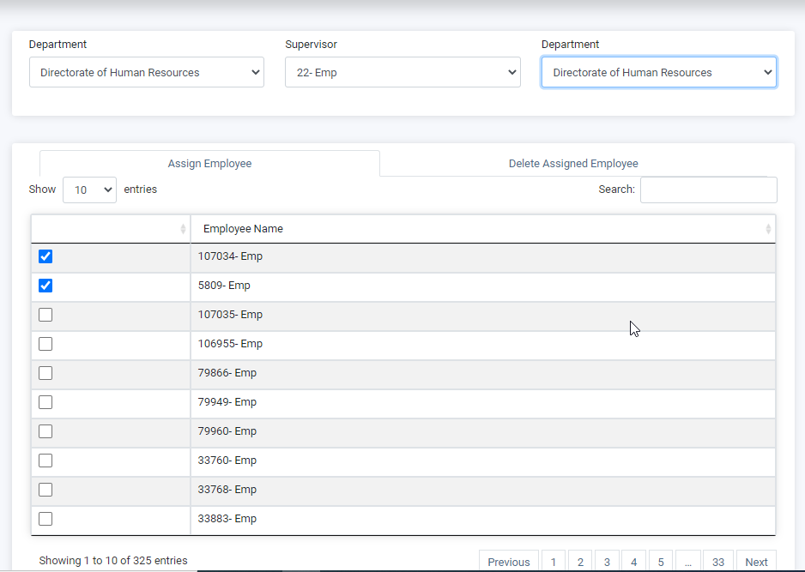

Fig:18

* In fig: 18 the first department dropdown is for supervisor filteration and the second department dropdown is the employee lis of that particular department.
* After selecting the employee from the supervisor dropdown and then select second deparparmet dropdown, the assign employee grid comes. Just checked the check box and save it. Those employees will be assigned under that supervisor.
* To remove the employee assignment just go to the next tab “Delete Assigned Employee”. Click on the  button and save it. See fig: 19.

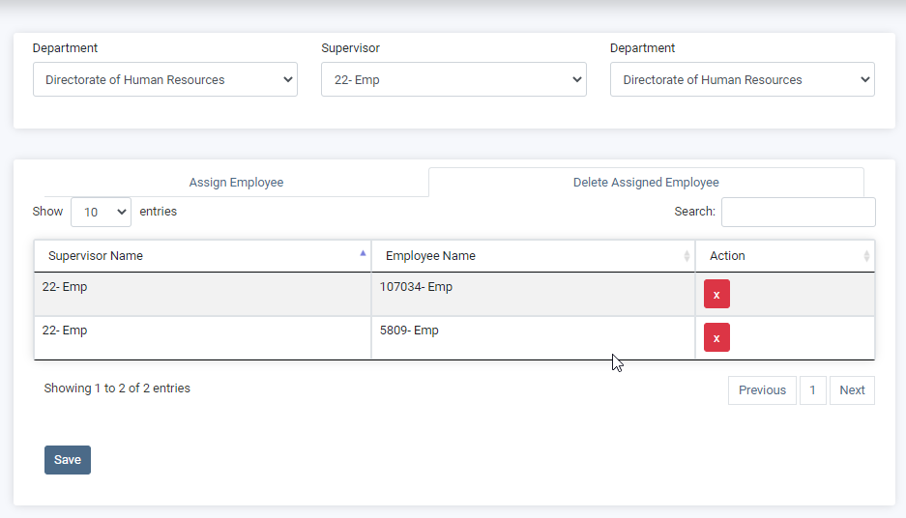

Fig: 19

* **Time Sheet**: From this module Admin user can fill up their task details.



Fig: 20

* If user is Admin he can only view other user task details. See fig: 21. In fig: 21 there is no “Save“ or “Add Row” button



Fig:21

* By default there are five rows in the task grid. If any employees need to fill up more than 5 task then he/she need to click on “Add Row” button.
* Task description and time is mandatory fields.
* Task category is an optional fields. To add new task category just click on this button. A pop pup will be open and enter task category name and save it. See Fig: 22.



Fig: 22

* To delete/add task details of a particulars date, select that date from the date time picker and Click on Go button. See fig: 23
* To find out the task details of a particulars date, just select that date from the date time picker. See fig23



Fig: 23

* **Time Sheet Report** From this report Admin User can view their own and other user task details report by selecting the date range and also select user from Employee dropdown list and also download the excel sheet. Fig: 24



Fig: 24

* **Check In and Check Out time**: In timesheetAdmin user just click on chek in and check out button to enter the check in and check out time. Fig: 25



**Fig: 25**

* **CheckIn Status Report:** from this report Admin user can view their own and other User check in and check out time details report by selecting the date range and also selecting user from Employee dropdown list . See fig: 26



fig: 26

* **Task Category:** From this module Admin User can add, edit or delete their own task category name. see fig: 27



Fig: 27

# 2. Kentico Admin Part for Admin User

* **Login**

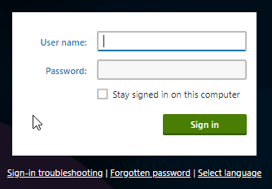

**Login URL:**

**Access**

Username—administrator

Password—blank

* **Custom Tables**

If you want to search the custom table for the particiapants then type the desired table name in the display name and click on search. After clicking on the search you will get the table which you want to see the properties. Click on the button from the list and you will get general details of the custom table.

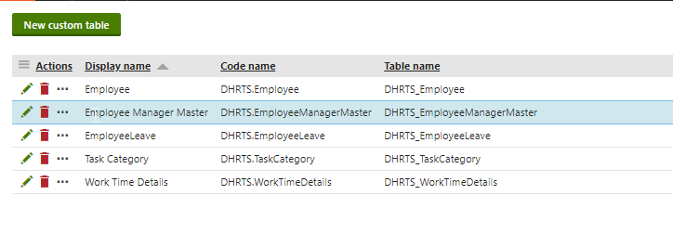

From here you can change/add new column into the table. The important thing is if you want to change/add column then contact to the developer. Added column will not be get populated in the module section or in registration form. It need coding to populate the controls in the module or registration form.

* **Custom Table Data**

To view the custom table data of the participants then click on the  icon and type custom table data. Click on the custom table data and you will get a list of custom tables. Click on the button on the desired table from the list.

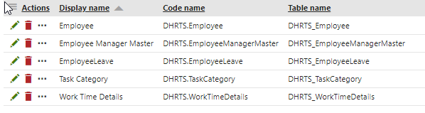

After clicking on the  icon you will get list of participant custom tables.

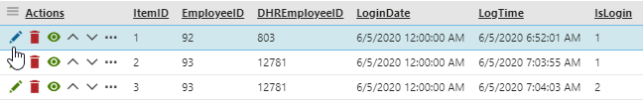

If you want to add new item then click on the  icon and you will get a form to insert data regarding to the custom table. But remind you that the dropdown control or the other control will appear as textbox. It will be difficult to maniputale the data from here. Better you can mannipulate the data from the module section.

* **Page Type**

Most of the items in the CMS are built in page types. News,Participant Category etc. inside the node of the Wafer. To get the page types click on the  icon and type Page Type in the search box. Now click on the page types you will get a list of page types.

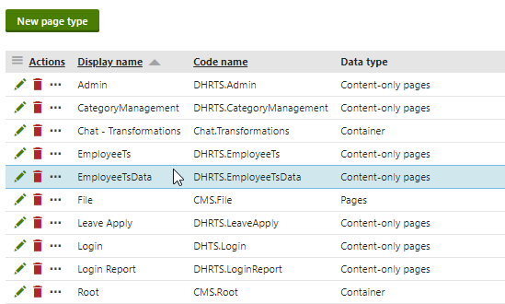

If you want to create a new page type then click on the New page type and you need to fill up the form for that particular page type.